Ball Wall
A Ball Wall or indeed any wall is a tremendous Hurling Resource and has been since the beginning of the game. How often have we listened to the Stars of the Game telling us about the hours and hours of practice they put in “Pucking a Ball against a Wall” or “going to the Alley!” The wall gives you the opportunity to get in far more touches than you might get at a conventional training session plus you can practice in your own time and on your own.
In order to play any game you need to have the skills and the more you practice them the better you get!
Hurling has many skills but the “Basics” which could also be called the “Essentials” can probably be put into the following headings:
- Striking
- Handling / Catching
- Rising (Jab & Roll)
- Hand passing
- Hooking
- Blocking
- First Touch
The following are a selection of skills that can be honed using the wall.
On your Own
- Striking
    - Both sides
    - High & Low
- Hand passing
- Catching
    - High & Low
- First touch
- Reaction / Footwork
- Meeting an oncoming ball at pace
- Overhead strike (if you have a back wall)
- Pulling on a moving ball (if you have a back wall)
- Accuracy (Paint targets on the wall)
- Blocking / Stopping the ball / High & Low
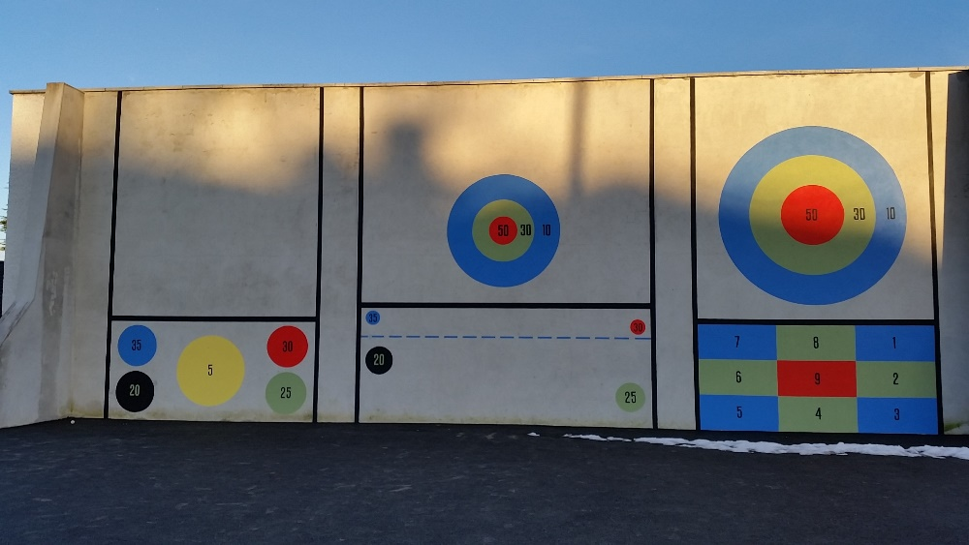
- Batting
With a colleague or more
- Hooking
- Blocking
- Competing for high ball
- Getting in for the break
- Anticipation
- Striking (Handball with Hurls)

