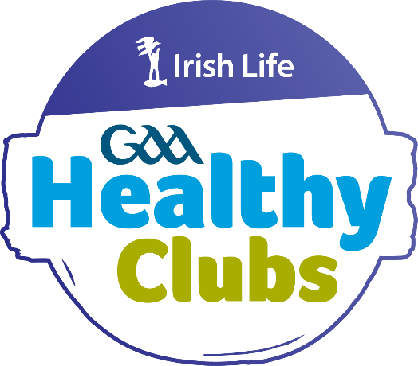

IRISH LIFE GAA HEALTHY CLUB PROGRAMME

FAQS

WHAT IS THE HEALTHY CLUB PROGRAMME (HCP)? WHAT IS THE AIM OF THE HCP?
WHAT DOES IT INVOLVE FOR PARTICIPATING CLUBS?
WHAT DOES THE HEALTHY CLUB, SILVER & GOLD AWARDS INVOLVE?
WHAT IS THE TIMELINE FOR THE HCP?
WHAT CLUBS ARE PARTICIPATING IN THE HCP? HOW ARE CLUBS SELECTED TO PARTICIPATE? WHAT ARE THE FUTURE PLANS?
WHY SHOULD A CLUB GET INVOLVED- WHAT ARE THE BENEFITS? WHAT SUPPORTS ARE AVAILABLE?
WHAT CHALLENGES MAY A CLUB EXPERIENCE? WHAT COMMITMENT IS INVOLVED?
WHAT DOES REPORTING INVOLVE?
HOW WILL HEALTHY CLUBS BE RECOGNISED?
HOW MIGHT THE HCP AFFECT CLUB FINANCES? WHERE CAN I GET MORE INFORMATION?

What is the Irish Life GAA Healthy Club Programme (HCP)?
The Irish Life GAA Healthy Club Programme is a new way of looking at health in the context of the GAA. Clubs organically provide meaningful opportunities to socialise, play, and enjoy regular physical activity opportunities. Being part of the Healthy Clubs programme builds on this foundation and provides clubs with a framework to ensure that all aspects on their club are health-enhancing and inclusive. The programme is supported by Irish Life, Healthy Ireland, and Tomar Trust.

What is the aim of the HCP?
The Healthy Club programme aims to transform clubs into hubs for health within their communities.
The HCP helps GAA clubs identify what they are already doing well, identify areas where they can or would like to improve, and empower them to ensure that everyone who engages with their club benefits from the experience in a health-enhancing way, be they players, officers, coaches, parents, supporters, or members of their local community.

The ultimate aim of the project is to involve every GAA club in the Association, thus enhancing the long-term health of every community in the 32 counties and ensuring a healthier future for everyone.

- What does it involve for participating clubs?
The initial steps to becoming a Healthy Club are included below. This takes place usually over an 18-month period but there is room for flexibility depending on club resources and capacity. Clubs must document their progress on the online Healthy Clubs Portal and when verified, they will gain recognition as a Healthy Club.
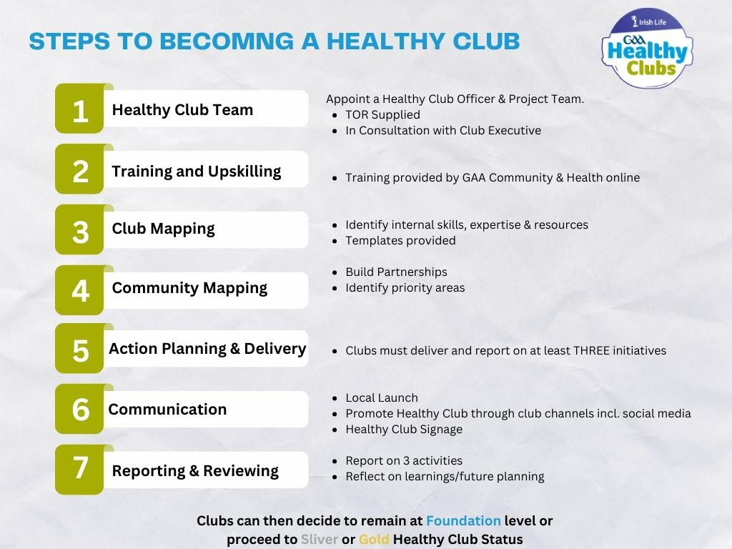

Healthy Clubs can subsequently strive for a Silver or Gold Healthy Club Award, if they have the desire and capacity to do so.

- What does the Healthy Club, Silver & Gold Award involve?
Clubs who are newly recruited are recommended to just meet the Healthy Club award requirements initially. They can subsequently strive for a Silver or Gold Healthy Club Award, if they have the desire and capacity to do so. You can view the criteria through the links below:
Healthy Club- PowerPoint Presentation
Silver- PowerPoint Presentation
Gold- PowerPoint Presentation

What is the timeline for the HCP?
The below table outlines how the project has evolved from a small pilot in 2013 to a national- scale project.

Phase | Date | Clubs
1 | 2013 (Q1) – 2015 (Q3) | 18 (16 completed)
2 | 2016 (Q1) – 2017 (Q3) | 60 (58 completed)
3 | 2018 (Q1) – 2019 (Q3) | 150 (142 completed)
4 | 2020 (Q1 – 2021 (Q3) | 293 clubs (271 completed)
5 | 2022 (Q1- 2023 (Q3) | 450 clubs (392 completed)
6 | 2024 (Q1- 2025 (Q6) | 607 clubs (550 completed)
7 | 2026 (Q1)- 2027 | 800 clubs

What clubs are participating in the HCP
Visit https://www.gaa.ie/api/images/image/upload/t_q-best/prd/sgflyekep3f63c0cza1r.pdf for a list of participating clubs. Clubs are listed here once they receive official recognition.

How are clubs selected to participate?
Interested clubs across the Association are asked to complete an expression of interest form. This submission provides an overview of what clubs are already doing in the space of health and wellbeing, what capacity the club has to do more and why the club wants to get involved. A scoring system is used to identify clubs who are most suitable for the project considering the above points but also considering the socio- demographics of the club, the geographical location and club variation. Clubs that applied for the previous phase of the Healthy Club programme but were unsuccessful are also given additional weighting.

What are the future plans for the HCP?

The ultimate aim of the project is to involve every GAA club in the Association, thus enhancing the long term health of every community and ensuring a healthier future for everyone.

Why should a club get involved- what are the benefits?
In 2021, the GAA commissioned Just Economics to carry out a Social Return on Investment Analysis (SROI) of the Healthy Club Programme. The total value of the programme is almost €50 million. The headline return ratio is therefore 19:1, suggesting that €19 of value is generated for €1 of financial, volunteer, and in-kind investment.
Participants report:
  - increases in physical activity (10-25%)
  - adopting of healthier behaviours (40%)
  - New hobbies (17%) and friendships (51%)
  - improvements in life satisfaction, connectedness to other people and the community (the latter seeing the largest change)
For the GAA itself, we find the following benefits:
  - Greater involvement by participants in the GAA (joining, taking their children to training or attending games) (77%)
  - Improved reputation (78%)
  - More members/volunteers Participating clubs reported:
  - changes in policies and procedures such as smoke and vape free venue
  - healthy eating at training and after games
  - increases in the proportion of clubs that consider their club to be welcoming, representative of the community and well-utilised
  - Some improvement in the ease at which volunteers are recruited/retained

What supports are available to clubs involved in the HCP?
A broad number of supports are provided by the GAA and the HCP official partners:
  - Support from the GAA’s County, Provincial and National Health & Wellbeing Committees
  - Regional Community & Health Coordinators
  - The Healthy Club Co-ordinator and Community & Health Department staff
  - Experience from clubs who participated in previous pilots
  - Your Club and County executive committees
  - Your Healthy Club Project team (should ideally contain between 4 to 8 members)
  - Healthy Club exclusive resources

Each club must carry out a community mapping exercise and engage with local partners where synergies exist. These depend on the demographic and geographic location of the club. Feedback from clubs about useful partnerships include local primary and secondary schools, GPs, pharmacies, sports groups, community groups, local sports partnerships, local charities and businesses.

FAQS

What challenges may a club experience?
Some of the challenges experienced by clubs in previous phases included:
  - Club capacity: some clubs found it difficult to recruit personnel for their project teams and at times a lot of work fell onto the shoulders of just one person. The clubs that excelled had an active project team (between 4-8 people) and support from the Club Executive.
  - Resistance: some clubs referred to the “old school mentality” within their clubs which made the project at times a “hard sell”. However, the “small steps” message resonated with clubs and they kept “chipping away” and innovating around how to position this new type of activity within a traditional organisation.
  - Documentation: some clubs, particularly those with limited team members found the documentation element on the portal a challenge. The process and reporting element has since been refined and simplified to make it as user friendly as possible for volunteers. It is also necessary that some members of the Healthy Club team is familiar with computers to document the clubs progress as the accreditation process is done via the online portal.

What commitment is involved?
Selected clubs are given an Agreement Form with specific requirements and milestones for participation but generally it involves the following:
  - implementing the 7 Steps of Becoming a Healthy Club
  - adopting specific health – related policies
  - delivering 3 health- related initiatives.
  - attendance at national conferences (in person/online)
  - attendance at provincial information -sharing events (in person/ webinars)
  - attendance information -sharing events with your County Health & Wellbeing Committee and other clubs in your county

The aim is not to try and achieve too much, but to implement simple changes that can have a lasting positive effect on a club’s approach to health and wellbeing. Clubs who have already gone through the process advise to go “slow and steady” and “less is more”.

What does reporting involve?
Clubs are required to document their progress throughout the Healthy Club journey, questions are asked on the activities the clubs rolled out such as number of attendees, age groups, target population and general information on the activity.

How will Healthy Clubs be recognised?
Healthy Clubs recognition periods occur every two years (during Q3/Q4) where clubs receive official recognition upon completion of all steps via the online Healthy Club portal. This usually involves an exciting celebratory event in your province where the Healthy Club Officer is awarded with a plaque and certificate on behalf of the club.

How might the Healthy Club Project affect club finances?
  - The majority of activities carried out by clubs are cost neutral by engaging with local partners who can supply goods and services to clubs free of charge or at a reduced rate.

FAQS
  - Many clubs successfully sought grant aid for larger projects.

Where can you get more information?
Contact your County Health and Wellbeing Committees using the generic email address chair.hwc.COUNTY@gaa.ie, for example chair.hwc.CLARE@gaa.ie

If you have any further questions about the Healthy Club Programme then please contact Brid O’ Dwyer GAA’s Healthy
Club Coordinator Brid.odwyer@gaa.ie.

