
Template for course set up: (Copy and Paste)
F3 Youth Athletic Development Course
The Gaelic Games F3 Youth Athletic Development Level 1 Course is a face to face workshop of 6 Hours in duration. It consists of a mixture of practical and theoretical sessions with the aim to ensure the participants understand the approach of Athletic Development and the content.
This is a blended learning course with 8 online modules which must be completed before attending a face to face practical. All online modules and our practical workshop must be completed in order to receive a Gaelic Games certificate of completion.
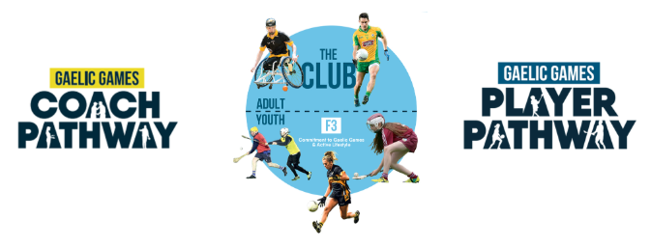
Date:
Time:
Venue:
Coach Developer:

Objectives:
- To understand the Player and Coach Pathway and Gaelic Games Sports Science Framework
- To educate coaches on the basics of Athletic Development
- To support coaches at the F3 Youth, T1/T2 stages
- To provide practical education to help you physically develop your players
- To provide accessible coach friendly resources for the pitch and hall environment
Duration:
- In Person Workshop: 6 hours
- Online E-Learning modules: There are 8 modules and approx. 15-30 mins to complete each module

