F1 Nursery Workshop

Descriptor:
The workshop is for coaches of Gaelic Games operating at F1 Nursery stage of the Gaelic Games Player Pathway. The course is aimed at beginner coaches from across the Gaelic Games codes of Hurling, Camogie, Gaelic Football, Ladies Gaelic Football, Rounders and Handball.
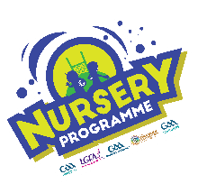

Objectives:
- Introduction to the Gaelic Games Player Pathway and underpinning principles
- Identify expectations from;
  - Player Characteristics
  - The Club Environment
  - Activities and Games
  - The Coach
- Highlight some coaching tips for coaching Nursery
- Introduce Fundamental Movement Skills suitable for Nursery
- List the 4 ‘How to Coach’ competencies & how to apply them into your Coaching
- Highlight some considerations for your club Nursery
- Introduce stations model and some suitable activities

Duration:
- In Person Nursery Workshop: 90 mins
- Online E-Learning Refresher Course: 15 mins

